Day in the Life of the Hudson River 10/13/22
Piermont Pier, Piermont
RIVER MILE: 25.4
Salt Front: ~ 76
Lamont Doherty Earth Observatory- Margie Turrin, Laurel Zaima, Marisa Annunziato
Tom Mullane & Pearl River HS, Shawn Kapusinsky & Spring Valley HS,
Alexis Dean & Clarkstown South HS, Liana Gertzer & Clarkstown North HS, and Brian Newburger & Tappan Zee HS
97 students & 14 adults
Latitude 41.043189 N & Longitude – 73.89595 W
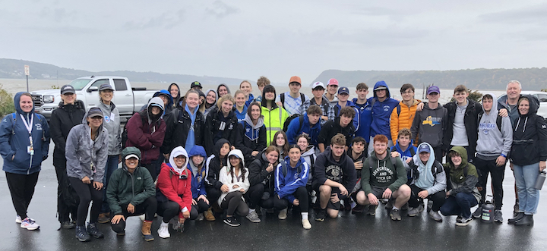
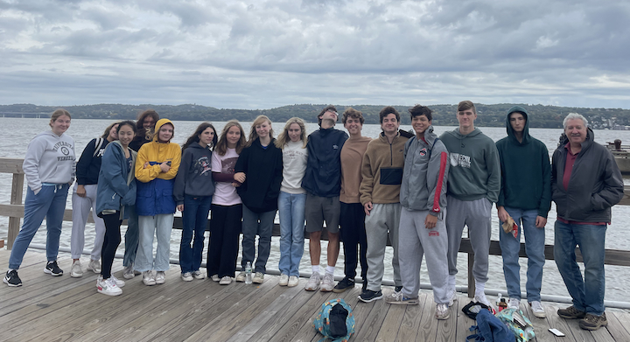 |  | 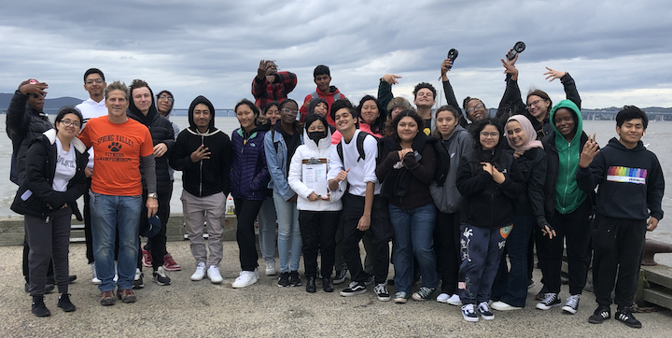
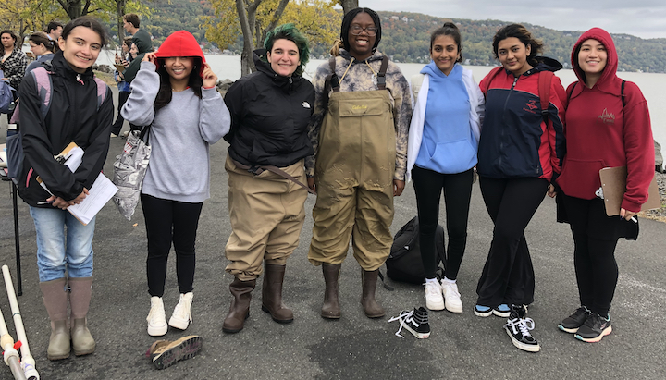 | 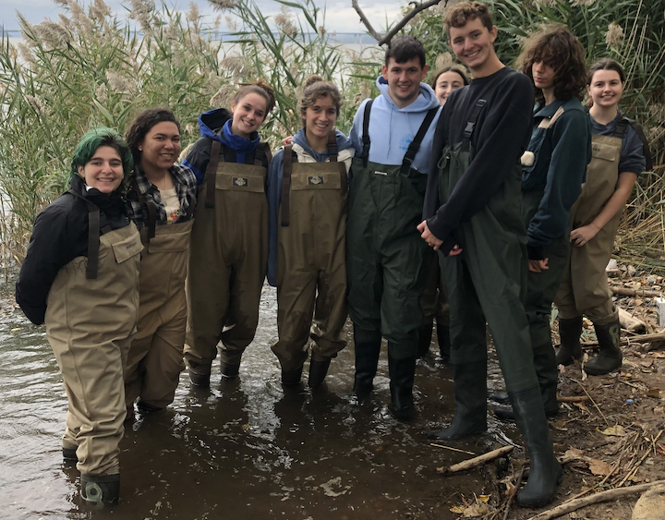 |  | 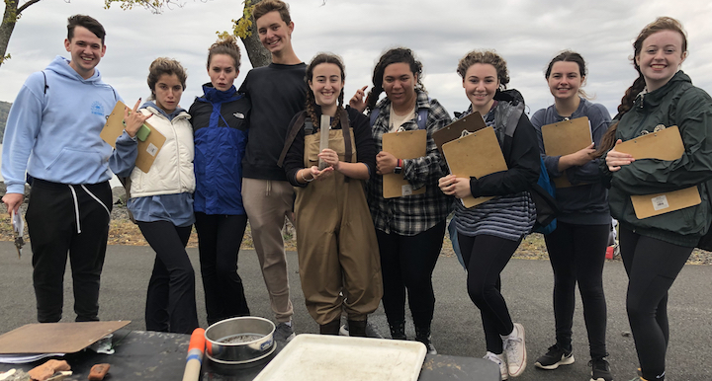

Location: Piermont Pier, Piermont, Rockland, NY
Area: Human made fishing/shipping pier at the east end, mile long pier with paved roadway and vegetated strip along both sides
Surrounding Land Use: 80% Urban/Residential; 20% Forested
Sampling Site: Pier, roadway in center of whole pier, parking area at the end, plants and trees along side. Shoreline riprap, collected wood in area and piping entering river on the south of sampling site
Water Depth: Varied by location on the pier and by the tide
Plants in area: 15% sumac and other plants; 85% phragmites; no submerged aquatic plants in water
River Bottom: Sandy, rocky bottom with phragmites growing in or near the water

*NR = Not read/recorded
ITEM |  | Time |  | Reading |  |  |  | Comments
Physical
Air Temperature |  | 9:22 AM  10:00 AM  10:30 AM  12:26 PM |  | 20º C  19 º C  20 º C  20.4 º C
Wind Speed: |  | 9:22 AM  10:00 AM  10:30 AM  12:26 PM |  | Anemometer  6 mph  7 mph  11.6 mph  21.5 mph |  |  | Beaufort  2  3  3  NR | Direction  SW  SW  SE  NR
Weather today |  | 10:30 AM |  | > 75% cloud cover |  |  | Drizzle
Weather the past 3 days: |  | Sunny, cool, Drizzling, rainy
Tides- measure water level change |  | Time |  | Rising, Falling, Unchanged |  |  | Water Height (cm)
Group 1  Group 2 |  | 9:00 AM- 12:04 PM  9:01 AM-12:15 PM |  | Rising  Rising |  |  | 340 cm  406 cm  373 cm  573 cm
Current- |  | Time |  | Cm/sec |  | Knots | North/South | Ebb/Flood/Still
 |  | 9:15 AM  9:50 AM  10:34 AM 10:50 AM  12:10 PM  12:20 PM  12:50 PM |  | 89.2  60.4  67.6  63.49  46.9  43.8  48.8 |  | 1.7  1.17  1.3  1.24  0.91  0.85  0.94 | North  North  North  North  North  North  North | Flood  Flood  Flood  Flood  Flood  Flood  Flood
Water Temperature- |  | 9:00 AM  10:00 AM  10:30 AM  12:00 PM  12:50 PM |  | 18°C GROUP 1  18.5° C  19° C  20° C  19° C |  |  | 9:15 AM  10:03 AM  10:30 AM  NR  12:55 PM | 18°C GROUP 2  19° C  18° C  NR  19° C
Turbidity-  Long sight tube (120 cm) |  | 9:17 AM  9:37 AM  10:00 AM  10:33 AM  11:03 AM  12:08 PM  12:30 PM  12:55 PM  1:00 PM |  | 18.16 cm  18.6 cm  17 cm  16.4 cm  20 cm  27.7 cm  25.1 cm  18 cm  27.2 cm |  |  | Secchi Disk (time)  9:19 AM  9:45 AM  10:05 AM  11:10 AM  12:15 PM  12:30 PM  1:00 PM  1:15 PM |  | Secchi Disk (cm)  25.3 cm  32.0 cm  24.5 cm  31.7 cm  33 cm  42 cm  36 cm  46 cm
Chemical
Salinity- GROUP1  Refractometer |  | 9:00 AM  10:00 AM  10:30 AM  12:00 PM  12:55 PM |  | 11,000 ppm  8,000 ppm  11,000 ppm  11,000 ppm  10,000 ppm |  |  | 9:10 AM GROUP2  10:03 AM  10:30 AM  1:00 PM | 10,000 ppm  10,000 ppm  10,000 ppm  10,000 ppm
Standardized Salinity – Refractometer |  | 9:05 AM |  | 10,000 ppm
DO – Hach Drop Count Kit |  | Time |  | Temp |  |  | ppm DO | % saturation
 |  | 9:22 AM  9:30 AM  10:00 AM  10:03 AM  10:30 AM  10:30 AM  12:00 PM  12:00 PM  12:55 PM  1:00 PM |  | 18° C  18° C  19° C  19° C  18° C  19° C  20º C  20° C  19° C  19° C |  |  | 10  8  10  8  9  9  9  10  10  10 | NR  85%  NR  85%  NR  95%  NR  110%  110%  NR
pH – Color Match Kit |  | 9:20 AM  9:22 AM  10:00 AM  10:03 AM  10:30 AM  10:30 AM  12:00 PM  12:50 PM  12:55 PM |  | 8.5  8  8.5  8  7.5  7  8  8  7.5
Nitrates- Lamotte Kit |  | 9:00 AM  9:20 AM  10:00 AM  10:03 AM  10:30 AM  10:30 AM  12:00 PM  12:00 PM  12:55 PM  1:00 PM |  | 0.8 ppm  0.8 ppm  0.8 ppm  0.4 ppm  0.6 ppm  0.5 ppm  0.6 ppm  0.4 ppm  0.4 ppm  0.4 ppm
Phosphates- Lamotte Kit |  | 9:00 AM  9:30 AM  10:00 AM  10:03 AM  10:30 AM  10:30 AM  12:00 PM  12:00 PM  1:00 PM |  | 0.64 ppm  0.5 ppm  0.2 ppm  0.5 ppm  0.22 ppm  0.55 ppm  0.28 ppm  0.32 ppm  0.62 ppm
Alkalinity- Lamotte Kit |  | 10:30 AM  12:00 PM  12:00 PM  12:55 PM  1:00 PM |  | 66 ppm  62 ppm  72 ppm  60 ppm  72 ppm
Biological
Fish – Seine |  | Number |  | Name |  |  | Length of longest | Length of smallest
9:20 AM- 1:15 PM |  | 253  5  4  1 |  | Atlantic Silverside  Striped Bass  Atlantic Menhaden  Atlantic Herring
Fish Totals |  | TOTAL: 263 |  | Diversity: 4
Macroinvertebrates |  | Number |  | Name |  |  | Length of longest | Length of smallest
 |  | 8 (3M & 5F)  ~1500  ~50 |  | Blue Crab  Moon Jelly  Ctenophore sp.
Macroinvertebrate Totals |  | TOTAL: 1558 |  | Diversity: 3
Sediment Core
Length | H2S smell |  | Oxid Top |  | Oil |  | Grain Size | Other Features
9.5 cm  3.8 cm  13 cm  13 cm  4 cm  12 cm  13.6 cm  14.5 cm  6 cm | No  No  No  No  No  Yes  Yes  Yes  No |  | No  No  No  No  No  No  No  No  No |  | No  Yes  No  Yes  No  Yes  No  Maybe  No |  | Abundant: clay, mud, sand, gravel  Common: pebbles  Abundant: Mud Common: clay, gravel, pebbles  Rare: sand  Abundant: clay, mud  Common: sand  Rare: pebbles  Abundant: sand  Common: clay, mud, pebbles  Rare: gravel  Abundant: sand  Common: gravel  Rare: mud, pebbles  Abundant: clay, mud, sand, gravel  Rare: pebbles  Abundant: clay, mud  Common: sand  Rare: gravel, pebbles  Common: clay, mud  Rare: sand, gravel, pebbles  Abundant: sand, gravel  Common: mud  Rare: pebbles | Common: wood, shells  Rare: leaves, macroinvertebrates, living vegetation, coal, brick, slag  Rare: coal, living vegetation  Common: living vegetation  Abundant: leaves  Common: wood, living vegetation  Rare: coal  Rare: brick, coal  Common: wood  Rare: brick, coal  Common: leaves, living vegetation  Common: living vegetation  Rare: leaves, brick, coal  Rare: leaves, wood, brick, living vegetation
Boats-NR
 | Time |  | Name |  | Color |  | North/Southbound | Light/Loaded
Commercial
Residential

